Print Director TM
Installation Guide

© Blue Swift Software CC
Blue Swift Technologies is the
trading name of Blue Swift
Software CC
Reg No. CK2002/006045/23

Document revision date: 24/10/2017
colin@blueswift.co.za

Print Director Installation Guide
© Blue Swift Technologies 2017 all rights reserved
Table of Contents
INSTALLING SOFTWARE 1
Determine the site requirements 1
Ensure compatible networking & operating system infrastructure exists 1
Check for an existing database server 1
Confirm device compatibility 1
Identify the tracking requirements 1
Identify machines requiring software installation 1
Determine the most efficient deployment strategy 2
Firewall issues 2
Preparing the site for implementation 3
Obtain access rights to relevant machines 3
Prepare any firewalls for required ports 3
Installation procedure 3
SQL Server Express Installation 4
Create the database 5
Completing the installation 5
Configuring the database connection on other machines 5
Remote deployment via Active Directory Group Policy 6
Add the database connection settings to the SetupPDAgent.msi file 6
Create a distribution point 6
Create a Group Policy Object 6
APPENDIX 1: TECHNICAL REQUIREMENTS 8
Database Requirements 8
Print Server Requirements 8
Operating System 8
Runtime 8
Free Hard Drive Space 8
RAM 8
CPU 9
Module Description 9
PDAgent 9
PDServer 9
Resource Manager 9
PD Reports 9
DBTools: 10
Port Usage 10
PDAgent 10
PDServer 10
Printers 10

Print Director Installation Guide
- 1 -
© Blue Swift Technologies 2017 all rights reserved
INSTALLING SOFTWARE
DETERMINE THE SITE REQUIREMENTS
Ensure compatible networking & operating system infrastructure exists
Print Director tracks Windows print servers on an Ethernet network. WAN networks are supported and the software can operate in Offline Mode (i.e. if the connection to the central database is lost, they will write transactions to a local MS Access DB).
Currently Unix, Linux and Macintosh print servers are not supported. However, printouts from client machines using these OS’s to Windows print servers will be tracked. Note the minimum requirements in Appendix 1.
Check for an existing database server
The Print Director database (PDDB2) is supported on Microsoft SQL Server 2005 – 2016 on both full and Express editions. Some sites may have an existing SQL Server that is used for other applications. It may be more beneficial to run PDDB2 on this server since it may be optimised for database services and have backup procedures already in place. Enquire with the system administrator whether the PDDB2 may be installed on this server and obtain an SQL Server Authentication username and password (ensure that the server supports Mixed Mode Authentication as required by Print Director).
If there is no existing SQL Server a machine must be allocated for an SQL Express installation. This could be the primary print server or any other machine.
Confirm device compatibility
In the unlikely event that no PCL, Postscript or RPCS driver is available for a particular printer, notify the reseller and confirm whether the current printer language is supported. If the site requires photocopier tracking, submit the device models to the reseller for confirmation of support by the controller terminals.
Identify the tracking requirements
Knowing exactly what the site needs to track is key to a successful implementation. Identify what types of print servers exist on site:
- Spooled print servers: A print server that has a number of shared printers set up. Clients then connect to these printer shares to print.
- Desktop print servers: Workstations that have a desktop inkjet or laser printer connected to the LPT or USB port.
- Direct-to-IP printing: Workstations that print directly to network connected printers. If the site is to make use of photocopier tracking or Secure Document Release/Follow Me functionality, ensure that the printers support the embedded Print Director module or the external hardware controller terminal.
Identify machines requiring software installation
PDServer:
Normally only one PDServer is required on a network. This is the module that communicates with the embedded software on the printers, and executes scheduled tasks (e.g. report emails and Active Directory Synchronisation).
There are cases however, where more than one PDServer is required. An example would be a client that has multiple sites connecting to a central database over a WAN. It would be

Print Director Installation Guide
- 2 -
© Blue Swift Technologies 2017 all rights reserved
advisable to install a PDServer at each site. If the WAN were to go down, users would still be able to log into the printers, as the local PDServer would continue operating in ‘offline mode’.
It must be noted however, that ‘follow me’ printing can only be conducted between printers that are managed by one PDServer. This means that if the user sends a job to a printer managed by PDServerA, that user would not be able to release their jobs at a printer managed by PDServerB.
PDAgent:
All print servers (spooled, desktop and direct IP workstations) will require the PDAgent software module. Client workstations that print to a print server will not need the PDAgent unless:
- They have any local direct-to-IP or USB print queues.
- They will perform popup account billing.
- They require popup user authentication.
- They require popup Rule violation notifications.
These machines must meet the minimum requirements (see Appendix 1). A reboot is not required and the installation can be pushed via Group Policy or a similar deployment system (e.g. Microsoft Systems Management Server - SMS).
Resource Manager:
Administrators that conduct tasks such as altering printout pricing and adding users and accounts will require the Resource Manager module. Ensure that their workstations meet the minimum requirements (see Appendix 1). No reboot is required.
PDReports:
Administrators that generate reports require the PDReports module. Confirm that these machines adhere to the minimum requirements (see Appendix 1). No reboot is required.
Determine the most efficient deployment strategy
If a site only requires a few software modules to be installed, it would most likely be more efficient to manually install at each machine. An example of such a site would be one with a few print servers and users that do not require the popup client.
Sites that require many software modules to be installed may need to make use of a remote deployment strategy. Remote deployment is possible in sites that require all machines and users to log on to an Active Directory domain controller. Group Policy objects can be configured in the Active Directory that governs the deployment of packages to specific machines. An example of such a site would be one with many workstations that all print directly to the IP of the printers. The PDAgent module can be remotely deployed to all these workstations. Another example is a site with all their users making use of popup account billing (to perform third-party account billing).
Firewall issues
The system administrator would need to be informed of the port requirements for Print Director. See Appendix 1 for details. Note that if Windows Firewall is used, the PDAgent modules automatically create an exception for themselves.

Print Director Installation Guide
- 3 -
© Blue Swift Technologies 2017 all rights reserved
PREPARING THE SITE FOR IMPLEMENTATION
Ensure that all of the following steps are performed in advance of the scheduled implementation (e.g. 1 week). This is especially relevant in sites that will use remote deployment (Group Policy / SMS).
Obtain access rights to relevant machines
- Database machine: If SQL Express is to be installed (i.e. the site does not already have an SQL Server), obtain an administrative username and password for the database machine.
- Manual deployment on each machine: Administrative access rights are required for the installation of all modules.
- Remote deployment via Active Directory: Sufficient access rights to edit Group Policy Objects will be required.
Prepare any firewalls for required ports
The PDAgent module will automatically add an exception for itself in Windows Firewall. When the client application for PDAgent starts up, Windows Firewall should display a window asking whether or not to unblock it.
If any third-party firewalls exist on site, they should be configured to open the required ports (see Appendix 1 for port numbers).
The installation of SQL Express should automatically add the required Windows Firewall exceptions if the Print Director installer is used. If SQL Express is installed independently, a firewall exception must be added for the sqlsvr.exe process and the sqlbrowser.exe manually.
INSTALLATION PROCEDURE
On insertion of the Print Director installation CD the following form should be automatically displayed. If it does not run automatically, execute PrintDirector.EXE from the CD.
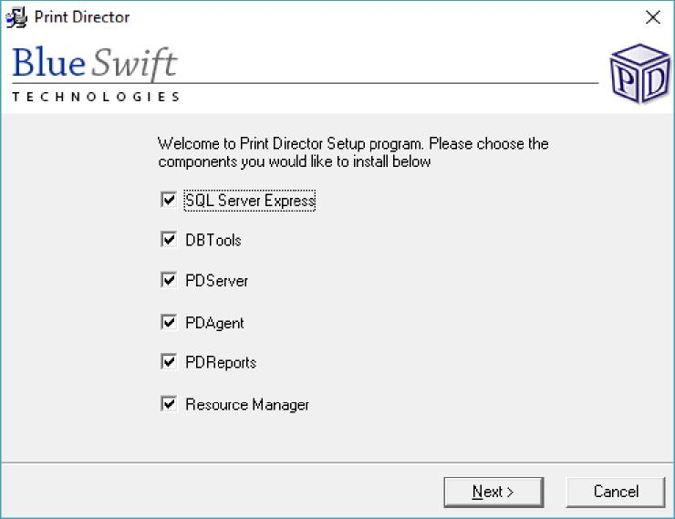

Print Director Installation Guide
- 4 -
© Blue Swift Technologies 2017 all rights reserved
Install only the packages required for the local machine. If all packages are required, leave all the checkboxes selected. Each package has its own setup wizard and each will execute sequentially (i.e. once the Database Tools is installed, the setup wizard for PDServer is executed.
SQL Server Express Installation
Click Next until the setup application for SQL Express is installed. At the end of the wizard the application will run, displaying the following screen:
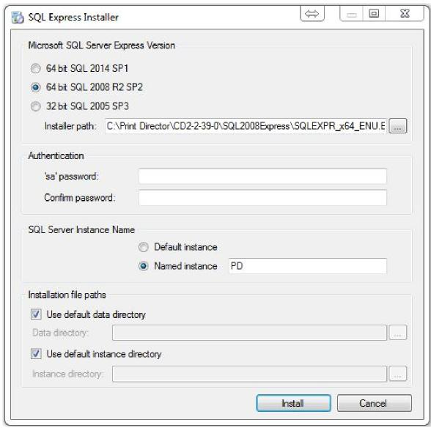
Choose the most appropriate version of SQL.
64 bit SQL 2014 SP1:
Use this version on Windows Server 2012 R2 or Windows 10 x64.
64 bit SQL 2008 R2 SP2:
Use this version on Windows Server 2008 x64.
32 bit SQL 2005 SP3:
Use this version on any 32bit operating systems.
Authentication:
Use a password that meets the policy requirements for the domain. It is recommended to use the standard password for the distributor. Please contact Blue Swift to find out what this should be. If the password doesn’t meet the domain requirements, ask the system administrator for a strong password recommendation.
SQL Server Instance Name:
If there is no existing default instance of SQL Server (check services.msc for SQL Server (MSSQLSERVER)) change the option to Default instance. Using the default instance means

Print Director Installation Guide
- 5 -
© Blue Swift Technologies 2017 all rights reserved
that the SQL Browser service is not required, and you don’t need to specify the instance name when entering database connection settings for other module installations.
Use the named instance ‘PD’ if there is an existing default instance of SQL Server that we can’t use for the PDDB2 database.
Accept the default data paths unless the system administrator requires them to be changed. Click the install button to begin the installation process.
Create the database
To create the database, DBTools must be installed. If the checkbox was selected on the initial screen, the wizard will begin after the SQL Express installation has completed.
Leave the Create the Print Director database check box ticked so the application is started once installed, and the database can be created.
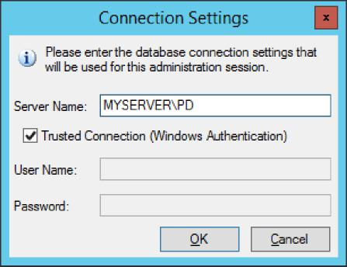
Enter the name of the SQL Server in the Server Name text box. If the server has a default instance of SQL Server then the server name is the same as the hostname of the database machine. If it has a named instance installed then the server name is MachineName\InstanceName (e.g. PDSERVER\PD). Leave the Trusted Connection check box ticked unless the server is on another machine on which the current logged-in user does not have sufficient access rights.
A form will be displayed showing the default data path for the new database. This is the default data path for the specified SQL Server. Do not change this path unless instructed to do so by the system administrator.
After the database has been created, a message will be displayed asking if a licence file should be submitted. Choose Yes and browse to where the licence file has been saved. If you do not have a licence file, contact your reseller.
Completing the installation
Once the database is created, the install wizard for PDServer will execute if the check box was selected on the initial install screen. Run through the installation of each package, accepting the defaults unless there are site-specific reasons not to.
Configuring the database connection on other machines
If modules are installed on machines other than the machine on which the database was created, the database settings will need to be configured. The form below will be displayed on startup of Resource Manager or PD Reports. In the case of an installation of PDAgent, the form will be displayed after the install wizard completes.

Print Director Installation Guide
- 6 -
© Blue Swift Technologies 2017 all rights reserved
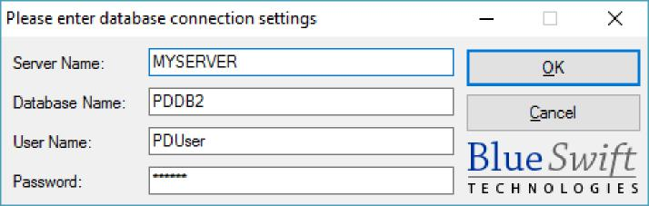
The server name is the machine name on which the SQL Server is running. If it is a named instance it will be MachineName\InstanceName (e.g. PDSERVER\PD). The username PDUser (password is PDUser) is filled in by default. This user account is created with the Print Director database. Accept these defaults unless specifically instructed not to by the system administrator.
REMOTE DEPLOYMENT VIA ACTIVE DIRECTORY GROUP POLICY Add the database connection settings to the SetupPDAgent.msi file
When the PDAgent is remotely deployed, a silent installation takes place where no user interfaces are displayed. This means the msi file must already have the database connection settings because the user won’t get an opportunity to enter them. To insert the settings, follow these steps:
- Open Resource Manager.
- In the menu bar, click Tools > Add database settings to msi file.
- A browse dialogue will appear. Locate the SetupPDAgent.msi file and click Open.
Create a distribution point
This is a shared folder on a server to which all users have ‘read’ access rights. It may be a good idea to add the ‘Domain Computers’ security group to the list of allowed ‘read’ objects. This is because it is actually the computer accounts that will be executing the installation. Copy the SetupPDAgent.msi file into this folder.
Create a Group Policy Object
- Open the Server Manager
- In the menu bar, click Tools > Group Policy Management.
- Under the domain forest, right click the container which will be linked to the new GPO. This container could be the root domain or an OU that contains the Computer Objects (NOTE: not user objects) that need the PDAgent installation. Choose Create a GPO in this domain, and Link it here...
- In the New GPO window, enter a name (e.g. PDAgent install).
- Now that the GPO has been created, the node will appear below the container. Right click this node and choose Edit... and the Group Policy Management Editor window will open.
- Under the Computer Configuration node, navigate to Policies > Software Settings > Software installation.
- In the right hand pane, right click and choose New > Package...
- A browse dialogue will appear. Here we have to specify to the path the distribution point that we created. We must use the network path, not the local path to the SetupPDAgent.msi file. Enter \\hostname (replace with correct hostname) in the File

Print Director Installation Guide
- 7 -
© Blue Swift Technologies 2017 all rights reserved
name textbox and click Open. You should see the shared folder of the distribution point
- Double click the shared folder and select the SetupPDAgent.msi file.
- Click Open.
- The next window should be the Deploy Software window. Leave the option Assigned selected and click OK.
Our software installation package should now appear in the list. When the client workstations are next rebooted, they will install the PDAgent automatically and connect to the database (as long as the Computer Objects are contained within the container to which the GPO is linked).

Print Director Installation Guide
- 8 -
© Blue Swift Technologies 2017 all rights reserved
APPENDIX 1: TECHNICAL REQUIREMENTS
DATABASE REQUIREMENTS
Print Director supports all versions of Microsoft SQL Server from 2005 to 2016. Express versions are fully supported. Please consult the Microsoft literature for the minimum requirements.
PRINT SERVER REQUIREMENTS
The minimum and recommended requirements listed below are expressed with the assumption that the server will not be running any other services (e.g. domain controller, Exchange, etc). Should the server be running other services, the specifications below should be adjusted accordingly.
Operating System
Print Director supports all Microsoft Windows operating systems from Windows Server 2003 to Windows Server 2012 R2. Desktop operated systems are supporting from Windows XP to Windows 10.
Runtime
Print Director is supported by the .Net Framework 2.0 through to 4.5. The only OS that might require an installation of .Net is Windows XP. All later versions of Windows have .Net pre-installed so no manual installation is required.
Free Hard Drive Space
Installation Files
The Print Director modules installed on a Print Server will use approximately 200MB of hard drive space.
Hard Drive Containing the Spool Folder
More importantly, the size of the hard drive on which the spool folder is hosted must be correctly allocated. Print Director holds the spool files for MFPs running in Secure Document Release mode on the server. Under this mode, the user must release their jobs at the device. Until the jobs are released, these spool files will be using space on the server hard drive. An auto-delete timeout can be set to limit the amount of time the jobs wait at the server.
Recommendations:
- 0-5 MFPs: 40GB free space
- 20-50 MFPs: 100GB free space
- 50-100 MFPs: 200 GB free space
RAM
The minimum requirement for RAM is 2GB. The recommended requirements are based on the number of MFPs hosted by the server:
- 0-4 MFPs: 2GB
- 5-20 MFPs: 4GB
- 20-100 MFPs: 8GB

Print Director Installation Guide
- 9 -
© Blue Swift Technologies 2017 all rights reserved
CPU
The minimum required CPU speed is 1.5Ghz single core. Recommended:
- 0-10 MFPs: 2Ghz dual core
- 10-40 MFPs: 2.6Ghz dual core
- 40-100 MFPs: 2.6Ghz quad core
MODULE DESCRIPTION
PDAgent
.Net Framework 2.0 windows service (supports all Windows operating systems)
- Monitors the print queues for the MFPs and printers.
- Prevents print jobs from exiting the queues (i.e. no changes to the port configuration or print processor are made).
- Waits for communication from PDServer before releasing the jobs (i.e. user logs in and selects the jobs for release).
- Required to be installed on the print server.
- Multiple PDAgents can be installed on multiple print servers and connected to the same DB.
- Connects to the SQL Server via ADO.Net.
- Can operate in Offline mode (i.e. if the SQL Server connection is lost it caches transactions to a local MS Access DB).
PDServer
.Net Framework 2.0 windows service (supports all Windows operating systems)
- Can be installed on a single server or multiple servers (multiple servers to prevent MFP authentication requests from going over unreliable WAN links).
- Performs communication with the embedded applications on the MFPs (Authentication and PullPrint).
- Executes scheduled tasks (e.g. report emailing and active directory synchronisation).
- Does not necessarily have to be installed on the print server. It communicates with PDAgent (to receive waiting job subscriptions and forward job release commands) via TCP/IP.
- Can operate in Offline mode (i.e. if the SQL Server connection is lost it caches transactions to a local MS Access DB).
Resource Manager
.Net Framework windows forms application (supports all Windows operating systems)
- Configuration module for print director.
- Used to maintain user PIN numbers.
- Used to maintain printer definitions and IP addresses.
- Used to install the embedded applications to the MFPs.
- Can be installed on multiple workstations and connected to the database.
PD Reports
.Net Framework windows forms application (supports all Windows operating systems)
- Reporting module for Print Director.
- Can be installed on multiple workstations and connected to the database.

Print Director Installation Guide
DBTools:
.Net Framework windows forms application (supports all Windows operating systems)
- Backup and restore of the DB.
- Clearing historical transactions.
- Can be installed on multiple workstations and connected to the database.
PORT USAGE
PDAgent
- Listens on TCP port 20111 for communication from other Print Director modules.
PDServer
- Listens on TCP port 20113 for communication from other Print Director modules.
- Listens on port 50002/50004 for communication from embedded Itec MFPs.
- Listens on port 5114 for communication from keypad attached MFPs.
- Listens on port 20114 for communication from embedded Lexmark MFPs.
PRINTERS
- Printers must have their primary drivers installed on a Windows print server with Windows 2000 or above.
- Supported printer languages: Postscript Levels 1, 2, 3. PCL 3, PCL 4, PCL 5, PCL 5e, PCL XL (PCL 6), Ricoh RPCS.

Blue Swift Technologies makes no warranty of any kind with regard to this material, including, but not limited to, the implied warranties of merchantability and fitness for a particular purpose.
- 10 -
© Blue Swift Technologies 2017 all rights reserved
All trademarks used in this document are the property of their respective owners. All other material is the property of Blue Swift Technologies. This document cannot be reproduced in whole or in part without prior written consent of Blue Swift Technologies. The information contained in this document is subject to change without notice.

